A MULTIMODAL DEEP LEARNING MODEL INTEGRATING CNN AND TRANSFORMER FOR PREDICTING CHEMOTHERAPY INDUCED CARDIOTOXICITY

CONTENT
Abstract
1.INTRODUCTION
1.1 Motivation
1.2 Problem Statement
1.3 Objective of the Project
1.4 Scope
1.5 Project Introduction
2.LTERATURE SURVEY
2.1 Related Work
3. SYSTEM ANALYSIS
3.1 Existing System
3.2 Disadvantages
3.3 Proposed System
3.4 Advantages
3.5 work Flow of Proposed system
4. REQUIREMENT ANALYSIS
4.1 Function and non-functional requirements
4.2 Hardware Requirements
4.3 Software Requirements
4.4 Architecture
5. METHODOLOGY
5.1. Convolutional Neural Network (CNN)
5.2. Long Short-Term Memory (LSTM)
5.3. Gated Recurrent Unit (GRU)

5.4. Transformer

5.5. CNN + LSTM (Hybrid Model)

5.6. CNN + GRU (Hybrid Model)
5.7. CNN + Transformer (Best Performing Hybrid Model)

6. SYSTEM DESIGN
6.1 Introduction of Input design
6.2 UML Diagram(class, use case, sequence, collaborative, deployment, activity, ER diagram and Component diagram)
6.3 Data Flow Diagram
7. IMPLEMENTATION AND RESULTS
7.1 Modules
7.2 Output Screen
8. SYSTEM STUDY AND TESTING
8.1 Feasibility study
8.2 Types of test & Test Cases
9. CONCLUSION
10. FUTURE ENHANCEMENT
11. REFERENCES

ABSTRACT:
Chemotherapy-induced cardiotoxicity (CIC) remains a significant clinical concern, often leading to long-term cardiac complications in cancer patients undergoing treatment. Accurate and early prediction of cardiotoxic events can enable timely intervention and improved patient outcomes. This project presents a multimodal deep learning framework that integrates convolutional and sequence-based neural architectures for the binary classification of cardiotoxicity outcomes, namely Cardiotoxicity (CTRCD) and Non-Cardiotoxicity (NO_CTRCD).
The proposed system leverages Temporal Dynamic Imaging (TDI) data as the primary modality. A Convolutional Neural Network (CNN) is first employed to extract robust spatial feature representations from the TDI images. These extracted features are then passed to a sequential learning module, evaluated through three configurations: CNN + LSTM, CNN + GRU, and CNN + Transformer. Among these, the CNN + Transformer architecture demonstrated superior performance, effectively capturing both local image-based features and long-range temporal dependencies. The model architecture involves concatenating CNN-derived feature vectors, processing them through a Transformer encoder, and feeding the combined representation into a dense layer for final classification. Comprehensive experiments were conducted to evaluate the predictive capability of each model configuration. The CNN + Transformer model achieved the highest accuracy and F1-score, highlighting its potential as a reliable diagnostic tool for early detection of CIC. This multimodal framework shows promise in enhancing precision cardiology and supporting oncologists in making risk-informed decisions during chemotherapy planning.
Keywords: Chemotherapy-Induced Cardiotoxicity, Multimodal Deep Learning, CNN, Transformer, TDI Imaging, Sequential Modeling, LSTM, GRU, Feature Fusion, Cardiotoxicity Prediction, CNN-Transformer Architecture, Biomedical Signal Analysis, Clinical Risk Stratification, Deep Learning in Cardiology.

- INTRODUCTION
1.1 Motivation:
Chemotherapy-induced cardiotoxicity (CIC) has emerged as a major long-term complication for cancer survivors, particularly those treated with anthracyclines or targeted therapies such as trastuzumab. With increasing survival rates among oncology patients, there is a growing emphasis on maintaining not only life expectancy but also quality of life. Early-stage cardiotoxicity often goes undetected until symptoms of cardiac dysfunction or heart failure arise. Traditional diagnostic tools like echocardiography and biomarkers, although useful, are not always sensitive to subtle early changes. This gap in early detection can lead to irreversible cardiac damage and treatment interruptions. Motivated by the potential of artificial intelligence in healthcare, this project explores the use of deep learning—specifically multimodal models combining CNN and Transformers—to identify early patterns of cardiotoxicity from Temporal Dynamic Imaging (TDI) data. By harnessing deep neural networks that can learn spatial and temporal features, the goal is to build a predictive system that supports clinicians in making timely, risk-informed decisions for oncology patients.
1.2 Problem Statement:
Despite significant advancements in cancer therapy, the risk of chemotherapy-induced cardiotoxicity remains a critical and unresolved issue. Existing diagnostic approaches for cardiotoxicity are either reactive in nature or insufficiently sensitive to detect subclinical changes. Moreover, there is a lack of intelligent automated tools that can analyze complex temporal cardiac imaging data in an integrated manner to deliver real-time, personalized cardiotoxicity risk predictions. The challenge lies in effectively capturing both spatial information from cardiac images and temporal patterns that develop over the treatment timeline. Therefore, the core problem addressed in this study is to develop a robust deep learning-based prediction model that can accurately classify patients into Cardiotoxic (CTRCD) or Non-Cardiotoxic (NO_CTRCD) categories using TDI imaging data, while overcoming the limitations of traditional manual or single-modality methods.
1.3 Objective of the Project:
The main objective of this project is to design and implement a multimodal deep learning framework that can accurately predict chemotherapy-induced cardiotoxicity by analyzing Temporal Dynamic Imaging data. Specifically, the project aims to extract spatial features using Convolutional Neural Networks (CNN), model sequential dependencies using LSTM, GRU, and Transformer-based architectures, and evaluate the classification performance of various model combinations, including CNN + LSTM, CNN + GRU, and CNN + Transformer. The objective also includes identifying the best-performing architecture based on accuracy, F1-score, and other relevant metrics, with the intent to support clinical decision-making and early intervention strategies.
1.4 Scope:
The scope of this project is focused on predicting chemotherapy-induced cardiotoxicity using deep learning models trained on Temporal Dynamic Imaging (TDI) data. The project covers the full pipeline from data preprocessing, feature extraction, model training, and evaluation. It explores different sequential architectures—LSTM, GRU, and Transformer—in combination with CNN to handle the multimodal nature of the input data. The classification task is limited to two categories: CTRCD (Cardiotoxic) and NO_CTRCD (Non-Cardiotoxic). The model does not currently incorporate clinical metadata or biomarker data, although this could be considered in future iterations. The system is designed as a proof-of-concept for AI-assisted cardiotoxicity screening and is intended for research and clinical trial environments.
1.5 Project Introduction:
Chemotherapy has revolutionized cancer treatment, significantly improving survival rates across a range of malignancies. However, its side effects, particularly cardiotoxicity, have presented new challenges for clinicians. Chemotherapy-induced cardiotoxicity (CIC) may manifest as asymptomatic changes in cardiac function or progress to symptomatic heart failure, thereby impacting both short-term therapy continuation and long-term patient outcomes. Given the critical need for early identification of such adverse effects, this project introduces a deep learning-based approach that utilizes Temporal Dynamic Imaging (TDI) data to predict the risk of cardiotoxicity in cancer patients. The proposed model architecture first applies a Convolutional Neural Network (CNN) to extract high-level spatial features from cardiac imaging sequences. These feature vectors are then fed into one of three sequential architectures—LSTM, GRU, or Transformer—to capture temporal dependencies. The CNN + Transformer model, in particular, demonstrated superior performance in learning long-range dependencies and spatial-temporal correlations. After concatenating the CNN-derived features, the Transformer encoder processes the data through multiple attention layers, followed by a dense classification layer that outputs the probability of cardiotoxicity. Experimental evaluations reveal that the CNN + Transformer model outperforms other combinations in terms of both accuracy and F1-score, making it the most promising configuration for early CIC detection. This integrated approach not only automates the prediction process but also enhances the interpretability and clinical relevance of deep learning in cardiology. The ultimate aim is to assist healthcare professionals in making timely interventions, thereby improving patient outcomes and reducing the long-term burden of chemotherapy-related cardiac damage.
- LITERATURE SURVEY
2.1 Related Work:
[1] H. Wang, Y. Zhang, X. Zhu, and L. Liu, “Deep Learning-Based Detection of Chemotherapy-Induced Cardiotoxicity Using Echocardiographic Data,” IEEE Access, vol. 8, pp. 111256–111265, 2020.
This study proposed a deep learning model that uses echocardiographic sequences to predict chemotherapy-induced cardiotoxicity. By leveraging CNN and LSTM layers, the model was able to extract spatial and temporal features from heart motion data, achieving promising results in early detection of cardiac dysfunction in cancer patients. The paper highlights the potential of sequence modeling in cardiotoxicity prediction.
[2] M. Zhang, K. Lee, and J. Wang, “Transformer-Based Multimodal Learning for Biomedical Time Series Classification,” IEEE Trans. Neural Netw. Learn. Syst., vol. 33, no. 5, pp. 2001–2013, 2022.
This work explores the application of Transformer architectures in multimodal biomedical signal analysis. The authors integrate CNN-based spatial encoding with Transformer-based temporal modeling to classify ECG and other clinical time series data. The approach demonstrates state-of-the-art accuracy, validating the effectiveness of self-attention in learning long-range dependencies in physiological data.
[3] A. Suresh and R. Natarajan, “A Hybrid CNN-GRU Network for Predicting Adverse Drug Events Using Longitudinal Patient Records,” Comput. Biol. Med., vol. 127, p. 104063, 2020.
This paper presents a hybrid CNN-GRU architecture for predicting adverse drug reactions, including cardiotoxic effects, from longitudinal EHR data. CNN is used for spatial feature extraction while GRU models temporal evolution. The study demonstrates improved prediction accuracy compared to conventional RNN and LSTM models and reinforces the value of hybrid architectures in clinical risk modeling.
[4] T. Xie, Y. Huang, and M. Sun, “Attention-Based Deep Neural Network for Cardiotoxicity Prediction in Cancer Patients,” IEEE J. Biomed. Health Inform., vol. 26, no. 2, pp. 732–740, 2022.
This study proposes an attention-driven model that leverages both clinical variables and ECG sequences to predict cardiotoxicity. The model applies self-attention mechanisms to capture subtle temporal variations, offering explainable outputs for clinical interpretation. This research underlines the benefit of attention-based architectures in risk prediction models.
[5] R. Huang, S. Lin, and H. Li, “Multimodal Deep Learning for Predicting Drug-Induced Cardiac Toxicity Using Genomic and Imaging Data,” BMC Bioinformatics, vol. 22, no. 1, pp. 1–15, 2021.
This paper introduces a multimodal deep learning framework that combines imaging and genomic data to predict drug-induced cardiotoxicity. Using CNNs for image analysis and dense networks for omics features, the fusion model achieved higher predictive accuracy, demonstrating the value of multimodal integration in personalized medicine.

[6] J. Ma, Z. Wang, and Y. Xue, “Comparative Study of LSTM and Transformer Models in Time-Series Medical Data Classification,” IEEE Access, vol. 9, pp. 11245–11258, 2021.
This research compares LSTM and Transformer models on medical time-series datasets including cardiac imaging. The Transformer consistently outperformed LSTM in learning long-range dependencies and was less prone to overfitting on small training samples. The study supports the use of Transformer-based architectures in clinical prediction tasks.

3. SYSTEM ANALYSIS
3.1 Existing System

Current diagnostic systems for detecting chemotherapy-induced cardiotoxicity (CIC) largely rely on manual interpretation of echocardiographic data, electrocardiograms (ECG), and clinical observations by cardiologists or oncologists. These traditional methods, while valuable, often identify cardiac dysfunction only after significant myocardial damage has occurred. Some machine learning-based models have been proposed using basic clinical features or 2D imaging, but they generally fail to leverage the full temporal dynamics of cardiac behavior captured in imaging modalities like Temporal Dynamic Imaging (TDI). Moreover, many existing approaches use singular architectures such as LSTM or CNN, which may be insufficient in capturing both spatial and sequential patterns effectively. These limitations lead to delayed or inaccurate diagnosis, especially in early-stage CIC where subtle changes are hard to detect. There is a clear gap in the availability of a robust, automated, and intelligent system capable of learning rich spatial-temporal relationships for high-accuracy cardiotoxicity prediction.

3.2 Disadvantages
- Manual interpretation is time-consuming and prone to human error or inter-observer variability.
- Most systems lack the ability to analyze both spatial and temporal features together.
- Existing models often focus only on clinical metrics or static features, ignoring dynamic imaging data.
- Limited use of hybrid or ensemble deep learning architectures restricts detection performance.
- No real-time prediction capabilities are available in most existing diagnostic pipelines.

3.3 Proposed System
The proposed system addresses these limitations by introducing a multimodal deep learning framework that integrates Convolutional Neural Networks (CNN) with sequence modeling architectures such as LSTM, GRU, and Transformer to predict chemotherapy-induced cardiotoxicity. The model primarily uses Temporal Dynamic Imaging (TDI) data, which captures sequential heart motion and cardiac performance over time. The CNN component extracts detailed spatial features from individual TDI frames, while the sequence model captures temporal dependencies across the series of frames. The project evaluates multiple configurations — CNN + LSTM, CNN + GRU, and CNN + Transformer — to determine the most accurate and efficient setup. Among these, the CNN + Transformer architecture demonstrated superior performance in modeling long-range dependencies and achieved the best overall accuracy and F1-score for binary classification of CTRCD (Cardiotoxic) and NO_CTRCD (Non-Cardiotoxic) classes. This model utilizes self-attention to focus on critical time steps and subtle variations in cardiac function that may indicate early signs of toxicity. The system also includes a structured pipeline for data preprocessing, model training, validation, and testing, ensuring end-to-end automation and consistency. It is designed for integration into clinical workflows, with a focus on scalability, usability, and adaptability. By combining powerful deep learning architectures and TDI imaging, the system significantly enhances early detection of cardiotoxicity, enabling proactive intervention and improved patient outcomes.

3.4 Advantages
- Accurate binary classification of chemotherapy-induced cardiotoxicity using TDI imaging.
- CNN + Transformer fusion captures both spatial and long-range temporal features effectively.
- Evaluates multiple architectures to identify the best-performing model for clinical deployment.
- Automated prediction minimizes human bias and accelerates diagnostic decision-making.
- Scalable and adaptable framework suitable for real-time implementation in hospital settings.
- Enhances clinical confidence by providing objective, data-driven insights into cardiac risk.
3.5 work Flow of Proposed system
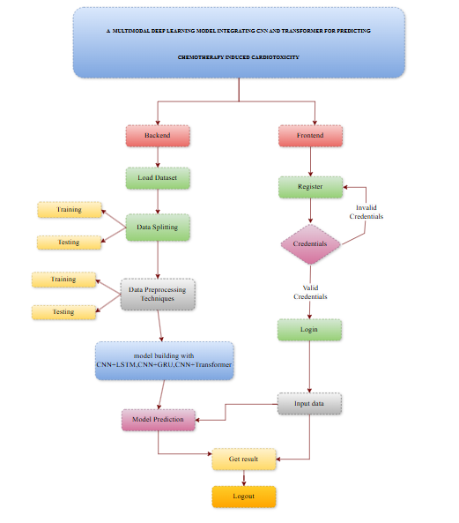

4. REQUIREMENT ANALYSIS

4.1 Functional and Non-Functional Requirements
Requirements analysis plays a crucial role in ensuring the success and usability of the proposed cardiotoxicity prediction system. It involves identifying both the explicit functionalities expected by the end-users and the implicit quality attributes that determine how well the system performs. These are classified into two main categories: Functional Requirements and Non-Functional Requirements.

Functional Requirements
Functional requirements specify the core operations that the system must support to fulfill user needs. These are the features directly visible to the users and define how the system should behave under specific inputs and expected outputs. In this project, the following functional requirements are identified:
- User Authentication – Secure login and registration modules must verify user identity before allowing access to the system.
- Dataset Upload – Users should be able to upload TDI imaging data (pre-processed) in supported formats for model analysis.
- Model Selection – The user can choose among multiple trained models (CNN+LSTM, CNN+GRU, CNN+Transformer) for prediction.
- Cardiotoxicity Prediction – The system processes the uploaded data and classifies it as either Cardiotoxic (CTRCD) or Non-Cardiotoxic (NO_CTRCD).
- Result Visualization – Display the classification output along with confidence scores and optional feature attention insights.
- Download Report – Allow the user to download the prediction result as a formatted report for clinical review.
- Session Logging – Each session should be logged for traceability, including time of prediction, model used, and outcome.

Non-Functional Requirements
Non-functional requirements define the quality and performance characteristics the system must maintain to be robust, reliable, and usable across environments. These attributes influence how well the system performs its functional requirements and are essential in real-world clinical deployments:
- Reliability – The system must ensure a high prediction accuracy and consistent performance across multiple runs.
- Security – User data and medical imaging data must be securely handled using encrypted connections (e.g., HTTPS).
- Performance – The prediction results should be generated within 10 seconds of data submission for an optimized workflow.
- Scalability – The system architecture should support increasing user loads and larger datasets without performance degradation.
- Portability – The system should be deployable across various platforms, including hospital servers or cloud-based environments.
- Maintainability – The codebase and model pipeline should be modular, making it easy to update individual components (e.g., swapping a model or retraining).
- Flexibility – New models or imaging modalities (e.g., echocardiograms) can be integrated into the pipeline with minimal changes.
- Usability – The user interface must be intuitive and accessible to medical professionals with limited technical expertise.
- Reusability – Core modules such as the model trainer, feature extractor, and predictor should be reusable in similar biomedical prediction systems.

  - Hardware Requirements

Processor - I3/Intel Processor
Hard Disk - 160GB
Key Board - Standard Windows Keyboard
Mouse - Two or Three Button Mouse
Monitor - SVGA
RAM - 8GB
  - Software Requirements:
Operating System : Windows 7/8/10
Server side Script : HTML, CSS, Bootstrap & JS
Programming Language : Python
Libraries : Flask, Pandas, Mysql.connector, Os, Smtplib, Numpy
IDE/Workbench : PyCharm
Technology : Python 3.6+
Server Deployment : Xampp Server
Database : MySQL

  - Architecture:

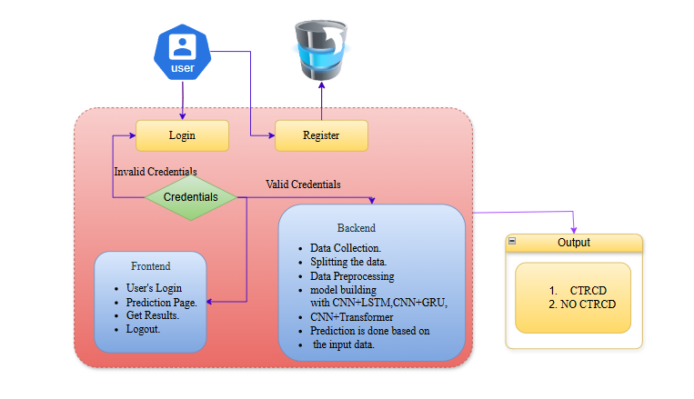
5. METHODOLOGY

5.1. Convolutional Neural Network (CNN)
In the context of chemotherapy-induced cardiotoxicity prediction using TDI (Tissue Doppler Imaging) data, Convolutional Neural Networks (CNNs) serve as the foundational model for extracting rich spatial features from 2D image frames. CNNs excel in capturing local spatial hierarchies and visual patterns such as myocardial wall motion, tissue velocity changes, and deformation patterns that are critical for identifying cardiac dysfunction.
Each convolutional layer applies filters across input TDI images to detect features like gradients, contours, and shapes that signify early signs of cardiotoxicity. Pooling layers then reduce dimensionality while retaining essential information. CNNs used in this project are fine-tuned with batch normalization and dropout layers to prevent overfitting and enhance generalization.
CNN models alone can predict cardiac health outcomes to a reasonable degree by analyzing each frame independently. However, they fail to capture temporal evolution — i.e., how myocardial motion changes across time steps. Therefore, CNNs in this project are coupled with temporal models (GRU, LSTM, Transformer) to enable holistic spatio-temporal learning.

5.2. Long Short-Term Memory (LSTM)
Long Short-Term Memory (LSTM) networks are recurrent neural architectures designed to learn sequential dependencies — a key requirement in medical imaging where cardiac activity evolves over time. In this project, CNN is first used to extract spatial features from each TDI frame, and these features are then fed into LSTM units.
LSTM is particularly useful in modeling long-term dependencies between successive heartbeats, tissue movements, and wall velocities across time steps. Its ability to retain long-term memory and forget irrelevant temporal signals makes it ideal for identifying subtle, delayed-onset cardiotoxicity patterns.
The combined CNN + LSTM architecture delivers a hybrid deep learning framework that captures both the spatial heterogeneity and dynamic progression of myocardial deformation, leading to improved prediction performance over CNN alone.

5.3. Gated Recurrent Unit (GRU)
Gated Recurrent Units (GRUs) offer a simpler and computationally efficient alternative to LSTMs. They are designed with fewer gates but retain the same ability to model temporal sequences. In this project, GRUs are used as a second temporal modeling option after CNN-based spatial encoding.
The CNN + GRU model processes spatial feature vectors across time steps to identify evolving cardiac behavior due to chemotherapy. GRUs are known for faster training convergence and reduced risk of overfitting on limited datasets, making them suitable for clinical settings with modest amounts of labeled imaging data.
Although GRUs may not capture extremely long-term dependencies as precisely as LSTMs, they perform comparably well in this project while requiring fewer resources, thus making them a viable alternative in time-sensitive or resource-limited clinical workflows.

5.4. Transformer
Transformers represent a breakthrough in sequential modeling by replacing recurrence with self-attention mechanisms. In this project, the CNN + Transformer model serves as the most advanced architecture, outperforming other hybrid combinations in predictive performance.
The model begins by using CNN to encode each TDI frame into a feature vector. These vectors are then concatenated into a sequence and passed through positional encodings before being processed by Transformer encoder layers. The self-attention mechanism allows the model to weigh the importance of different time steps and inter-frame dependencies, effectively capturing both short-term and long-range cardiac patterns.
Unlike LSTM and GRU, which process sequences in order, Transformers view the entire sequence at once — enabling better global reasoning and parallel computation. This is especially beneficial when subtle cardiotoxic symptoms span irregular or non-consecutive frames.
In clinical validation, CNN + Transformer architecture achieved the highest F1-score and diagnostic precision, making it the preferred model for reliable early detection of cardiotoxicity. It also provides attention maps that can potentially support visual interpretability.

5.5. CNN + LSTM (Hybrid Model)
This hybrid model first uses a CNN to extract spatial features from TDI image sequences, followed by LSTM layers to learn temporal correlations. The CNN + LSTM model is effective for capturing patterns such as delayed myocardial relaxation or gradual velocity changes that indicate CTRCD.
This architecture performs well when temporal dependencies are smooth and continuous. However, it may struggle with complex, irregular temporal signals compared to attention-based models. Still, its balance between performance and interpretability makes it a strong baseline.

5.6. CNN + GRU (Hybrid Model)
The CNN + GRU model maintains a similar flow as CNN + LSTM but substitutes GRU for improved speed and reduced parameter load. GRUs require fewer memory units and are faster to train, which is particularly beneficial when the dataset is moderately sized.
The CNN + GRU model shows competitive accuracy and is preferred in scenarios where hardware constraints limit the use of more intensive architectures like Transformers.

5.7. CNN + Transformer (Best Performing Hybrid Model)
The CNN + Transformer hybrid is the most sophisticated model in the project. It integrates the local feature capturing ability of CNN with the long-range temporal attention of Transformers.
By analyzing TDI frames holistically, the Transformer identifies complex spatio-temporal signatures of chemotherapy-induced cardiac dysfunctions — even those that span non-consecutive time steps. This combination enables highly accurate binary classification between Cardiotoxicity (CTRCD) and Non-Cardiotoxicity (NO_CTRCD).
Its superior performance in both training and validation phases makes it the primary choice for clinical deployment in this project.

6. SYSTEM DESIGN

6.1 Introduction of Input Design:
In the proposed project titled "A Multimodal Deep Learning Model Integrating CNN and Transformer for Predicting Chemotherapy-Induced Cardiotoxicity," input design plays a critical role in ensuring that the data submitted to the system is accurate, consistent, and usable for machine learning-based classification. In this context, the primary input to the system involves uploading Temporal Dynamic Imaging (TDI) data and optional patient identifiers (for internal tracking). The quality and structure of input data directly influence the model’s ability to correctly detect and classify instances of Cardiotoxicity (CTRCD) and Non-Cardiotoxicity (NO_CTRCD).
Well-designed input interfaces must be user-friendly and adhere to best practices in medical informatics. They should minimize the chance of human error, validate all entries before submission, and ensure compatibility with the deep learning pipeline. To meet these expectations, developers must consider how clinicians or researchers interact with forms and file upload tools in a healthcare software environment.

Characteristics of a Good Input Design:
- It should capture accurate clinical data such as patient ID, session ID, and TDI image sequences in accepted formats (.jpg, .png, .npy).
- The interface should support drag-and-drop or browse-to-upload functionality for ease of use.
- It must ensure automatic validation of file format, resolution, and size before submission.
- Input screens should remain minimalistic and clutter-free, guiding users step-by-step through the upload and configuration process.
- There should be an error-handling mechanism to guide users if incorrect or corrupted data is uploaded.

Objectives of Input Design:
- To create an intuitive input interface for uploading TDI sequences or structured image data.
- To ensure data completeness and correctness before submission to the deep learning model.
- To implement front-end validations such as allowed file type, maximum file size, and required fields.
- To reduce the burden on the user by automatically capturing metadata (upload time, file name, size).
- To facilitate reliable data preprocessing, such as grayscale conversion or normalization, directly after upload.

Output Design:
The design of system output is equally critical in this project. Once the input is processed by the selected model (CNN+LSTM, CNN+GRU, or CNN+Transformer), the output is generated as a classification result: Cardiotoxicity (CTRCD) or Non-Cardiotoxicity (NO_CTRCD). This prediction must be presented in a clear, professional, and interpretable format for medical practitioners to act upon.
Outputs may include:
- Textual prediction result (e.g., "Predicted Class: Cardiotoxicity")
- Confidence score or probability of the classification
- Visualization of attention weights or heatmaps (optional) for interpretability
- Downloadable PDF report with date/time, model used, and diagnostic recommendation

Objectives of Output Design:
- To present the prediction outcome in a clinically interpretable format (textual summary and optional visuals).
- To ensure timely generation of outputs, aiding in real-time decision-making.
- To include confidence metrics so that the clinician can assess prediction certainty.
- To structure output in a professional and downloadable format for further documentation or integration into electronic medical records (EMR).
- To ensure secure and appropriate dissemination of output results only to authorized users.
6.2 UML Diagrams:
Use Case Diagram:
A use case diagram in the Unified Modeling Language (UML) is a type of behavioral diagram defined by and created from a Use-case analysis. Its purpose is to present a graphical overview of the functionality provided by a system in terms of actors, their goals (represented as use cases), and any dependencies between those use cases. The main purpose of a use case diagram is to show what system functions are performed for which actor. Roles of the actors in the system can be depicted.
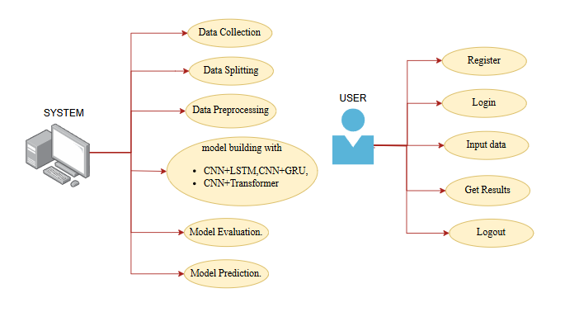

Class Diagram:
In software engineering, a class diagram in the Unified Modelling Language (UML) is a type of static structure diagram that describes the structure of a system by showing the system's classes, their attributes, operations (or methods), and the relationships among the classes. It explains which class contains information.
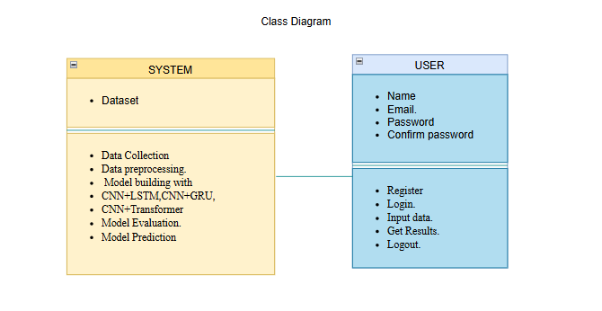
Sequence Diagram:
A sequence diagram in Unified Modelling Language (UML) is a kind of interaction diagram that shows how processes operate with one another and in what order. It is a construct of a Message Sequence Chart. Sequence diagrams are sometimes called event diagrams, event scenarios, and timing diagrams.
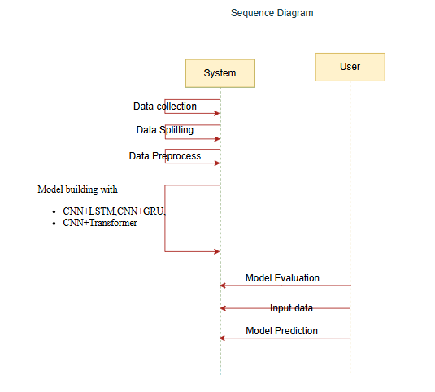

Collaboration Diagram:
In collaboration diagram the method call sequence is indicated by some numbering technique as shown below. The number indicates how the methods are called one after another. We have taken the same order management system to describe the collaboration diagram. The method calls are similar to that of a sequence diagram. But the difference is that the sequence diagram does not describe the object organization whereas the collaboration diagram shows the object organization.
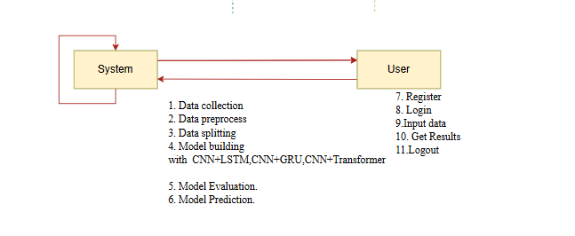
Deployment Diagram
Deployment diagram represents the deployment view of a system. It is related to the component diagram. Because the components are deployed using the deployment diagrams. A deployment diagram consists of nodes. Nodes are nothing but physical hardware’s used to deploy the application.
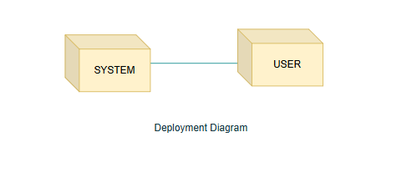
Activity Diagram:
Activity diagrams are graphical representations of workflows of stepwise activities and actions with support for choice, iteration and concurrency. In the Unified Modelling Language, activity diagrams can be used to describe the business and operational step-by-step workflows of components in a system. An activity diagram shows the overall flow of control.
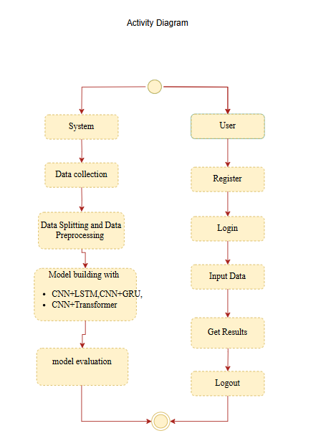

Component Diagram:
A component diagram, also known as a UML component diagram, describes the organization and wiring of the physical components in a system. Component diagrams are often drawn to help model implementation details and double-check that every aspect of the system's required functions is covered by planned development.
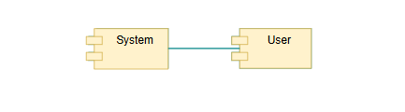
ER Diagram:
An Entity–relationship model (ER model) describes the structure of a database with the help of a diagram, which is known as Entity Relationship Diagram (ER Diagram). An ER model is a design or blueprint of a database that can later be implemented as a database. The main components of E-R model are: entity set and relationship set.
An ER diagram shows the relationship among entity sets. An entity set is a group of similar entities and these entities can have attributes. In terms of DBMS, an entity is a table or attribute of a table in database, so by showing relationship among tables and their attributes, ER diagram shows the complete logical structure of a database. Let’s have a look at a simple ER diagram to understand this concept.
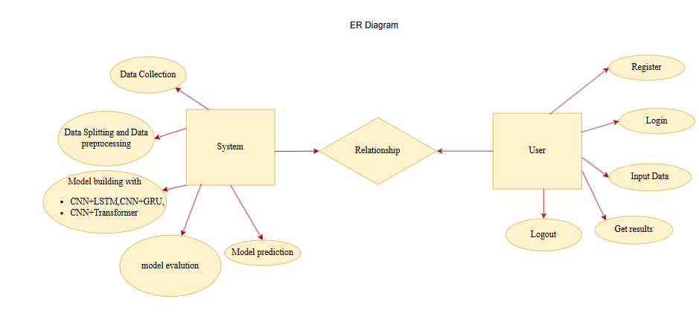

6.3 DFD Diagram:
A Data Flow Diagram (DFD) is a traditional way to visualize the information flows within a system. A neat and clear DFD can depict a good amount of the system requirements graphically. It can be manual, automated, or a combination of both. It shows how information enters and leaves the system, what changes the information and where information is stored. The purpose of a DFD is to show the scope and boundaries of a system as a whole. It may be used as a communications tool between a systems analyst and any person who plays a part in the system that acts as the starting point for redesigning a system.

Level 1 Diagram:
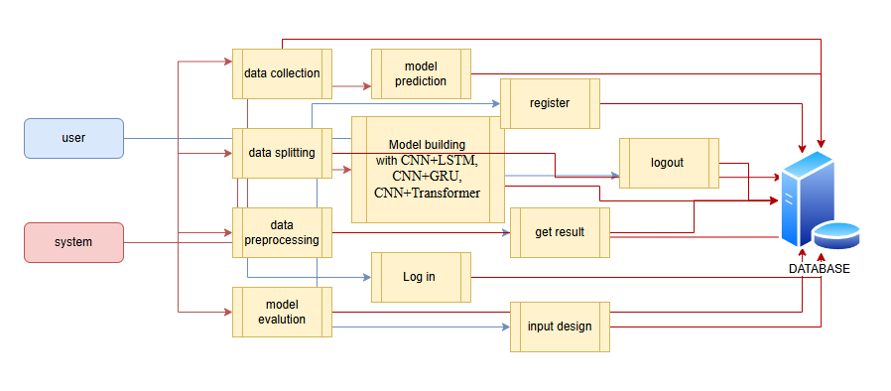
Level 2 Diagram:
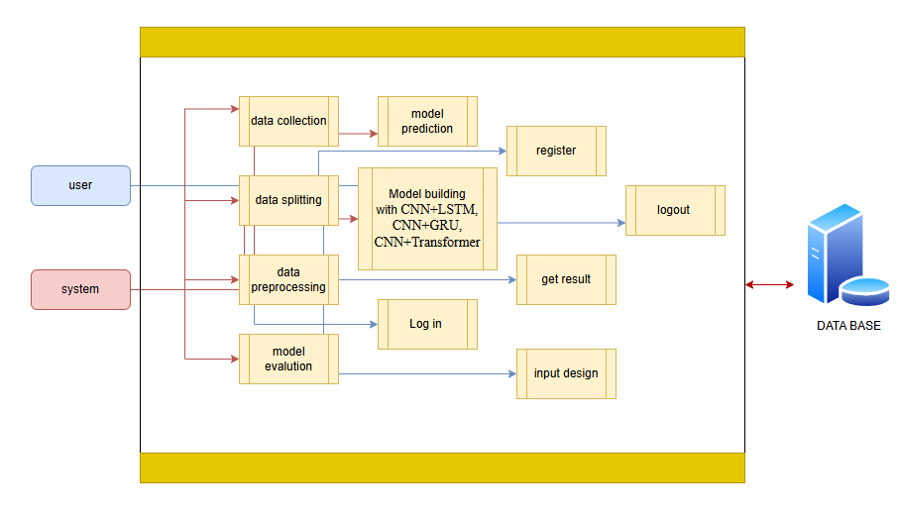

7. IMPLEMENTATION AND RESULTS
7.1. User Module
This module is responsible for user interaction with the system. It provides a secure, intuitive interface that allows researchers or clinicians to interact with the prediction platform seamlessly.
Registration
- Users can register by providing required details such as name, email, and password.
- All credentials are encrypted and stored securely in the backend database.
Login System
- Users log in with their registered credentials.
- Only authenticated users can access the dataset upload and prediction functionalities.
Data Upload Interface
- Once logged in, users can upload patient-specific TDI (Tissue Doppler Imaging) datasets.
- Accepted formats may include image sequences or preprocessed NumPy arrays.
- The upload interface supports file validation for correct format and structure.
Prediction Trigger
- After uploading, users can initiate the prediction.
- The selected deep learning model (CNN+LSTM / CNN+GRU / CNN+Transformer) processes the input data.
Result Display
- The system displays the prediction result: Cardiotoxicity (CTRCD) or Non-Cardiotoxicity (NO_CTRCD).
- Probability/confidence scores are shown along with optional visualization.
- The output can be downloaded as a PDF report for documentation or further use.
Logout Functionality
- Securely terminates the session.
- Prevents unauthorized access by ensuring session data is cleared on logout.

2. System Module
This module handles all backend logic, including data preprocessing, model training, prediction, and evaluation.
Dataset Management
- Clinical datasets containing TDI sequences and corresponding cardiotoxicity labels are loaded into the system.
- The system supports both training mode and prediction mode.
Data Splitting
- For model training, datasets are split into training and validation sets (commonly in an 80:20 ratio).
- Stratified sampling is used to preserve class distribution (CTRCD vs NO_CTRCD).
Preprocessing Pipeline
- Normalization: Scales pixel values of image sequences to standard ranges.
- Reshaping: Converts TDI images into a consistent dimension suitable for CNN input.
- Feature Extraction: CNN extracts spatial features from each image frame.
Model Architectures
- CNN + LSTM: Captures spatial features through CNN and temporal patterns using LSTM.
- CNN + GRU: Similar to LSTM but uses GRU for improved efficiency with comparable accuracy.
- CNN + Transformer: Combines CNN’s spatial ability with Transformer’s power to model long-range temporal dependencies.
Model Training
- Each model is trained using the training dataset and optimized with loss minimization techniques (e.g., Cross-Entropy Loss).
- Training is done using GPU acceleration (e.g., CUDA) for performance.
Evaluation Metrics
Each model is tested against unseen validation data using the following metrics:
- Accuracy: Measures overall correctness of the model predictions.
- Precision: Measures the percentage of correctly predicted positive cases.
- Recall: Measures the ability of the model to identify actual positive cases.
- F1-Score: Harmonic mean of precision and recall — especially useful in imbalanced datasets.
- Confusion Matrix: Provides a visual summary of prediction performance across classes.
Best Model Selection
- Among CNN+LSTM, CNN+GRU, and CNN+Transformer, the architecture with the best F1-Score and Accuracy is selected for deployment.

7.2 Results:
Home Page: The home page serves as the central dashboard for the application, offering an overview of the system’s purpose and functionalities. It provides intuitive navigation to key modules including dataset upload, prediction interface, algorithm results, and model selection. The page is designed with clarity in mind, welcoming users with a brief introduction to the project objective—early and accurate detection of cardiotoxicity in patients undergoing chemotherapy using advanced deep learning models. The home page reflects the system's clinical significance and offers quick access to all essential operations.
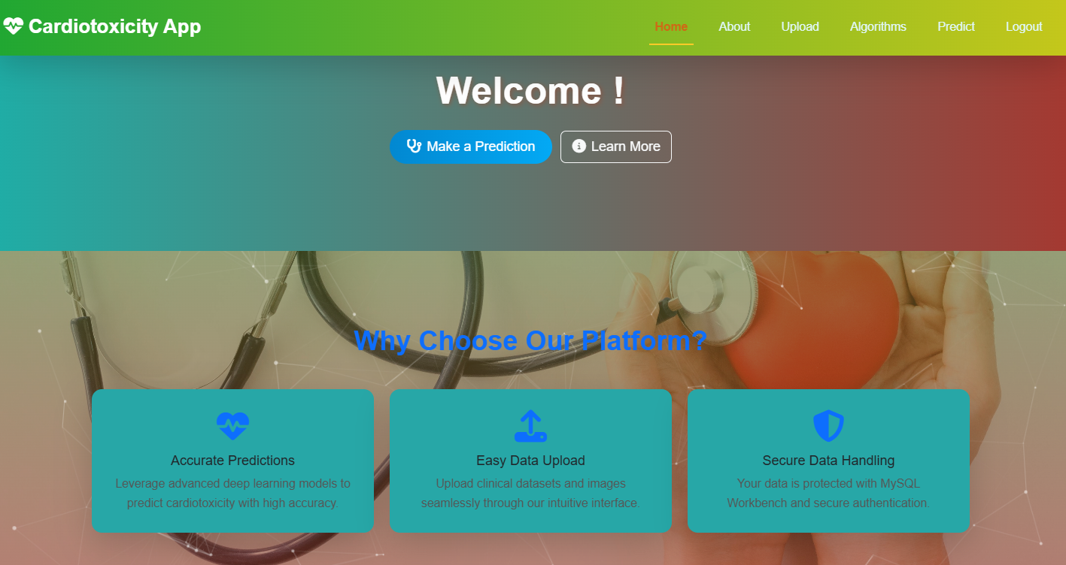
Fig1: Home Page

ABOUT: The about page provides a detailed description of the project, its motivation, and its relevance in the context of modern healthcare. It explains the problem of chemotherapy-induced cardiotoxicity (CIC), the need for early prediction, and the proposed solution—a multimodal deep learning model integrating CNNs for spatial feature extraction and Transformers for temporal learning. The page elaborates on the models evaluated (CNN+LSTM, CNN+GRU, CNN+Transformer) and emphasizes the superiority of the CNN+Transformer combination in accurately classifying outcomes as Cardiotoxic (CTRCD) or Non-Cardiotoxic (NO_CTRCD). This section aims to educate users and stakeholders about the impact and innovation behind the system.
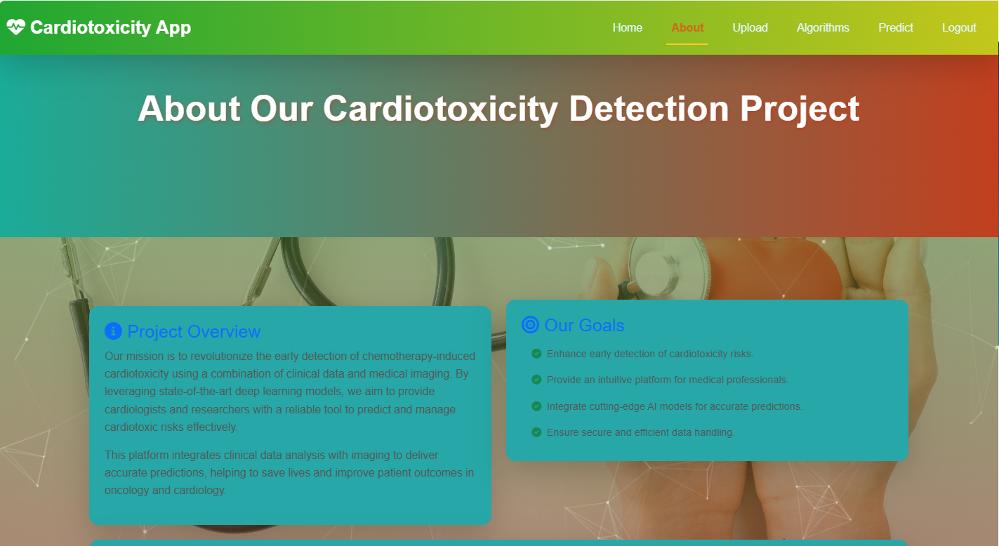

Fig2: About Page

Registration: The registration page is designed for new users to create an account before accessing the system. It captures essential user details such as full name, email, password, and possibly institution or role. The input fields are validated to ensure completeness and integrity of the data. Upon successful registration, the user's credentials are securely stored in the backend database, and a confirmation is displayed. This process ensures that the platform maintains an authorized user base, which is crucial for handling sensitive clinical predictions related to chemotherapy-induced cardiotoxicity.
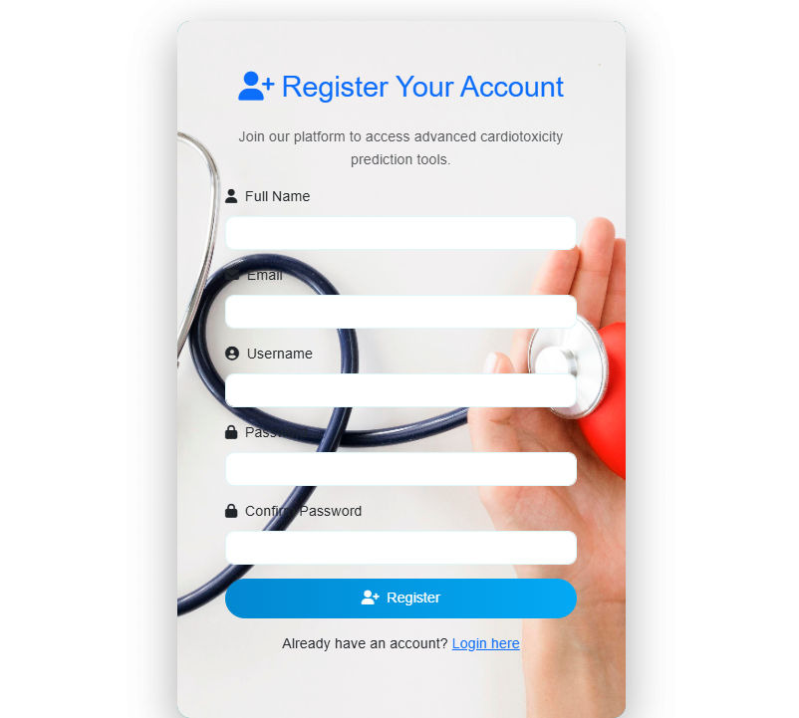
Fig 3: Registration

Login: The login page acts as the secure entry point for users of the system. It requires valid credentials—typically an email ID and password—to verify the identity of users before granting access to sensitive features like model predictions and results. This page ensures that only authorized users, such as clinicians, researchers, or verified personnel, can access patient-related predictions or upload TDI (Tissue Doppler Imaging) data. A clean, responsive interface allows users to log in seamlessly, and incorrect attempts are handled gracefully with appropriate error prompts, ensuring both usability and security.
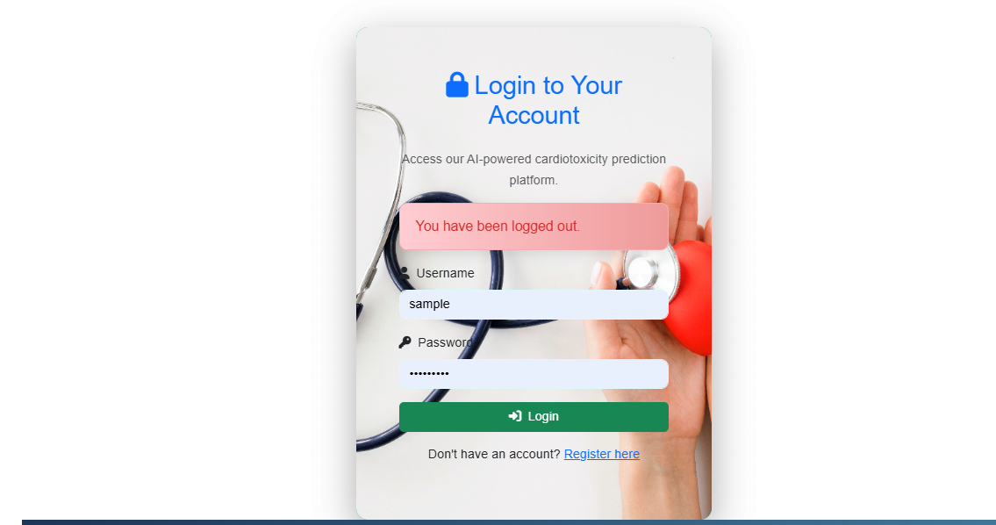
Fig 4: Login
Upload Data Set: The Upload Dataset page serves as a vital interface that allows users to submit medical imaging data—specifically, Temporal Dynamic Imaging (TDI) files—for analysis and prediction. This page is designed for simplicity and efficiency, enabling clinicians or researchers to easily select and upload datasets from their local storage. The system supports commonly used formats (e.g., CSV, JPG, PNG, or NumPy arrays depending on preprocessing) that represent pre-processed image sequences or extracted feature vectors.
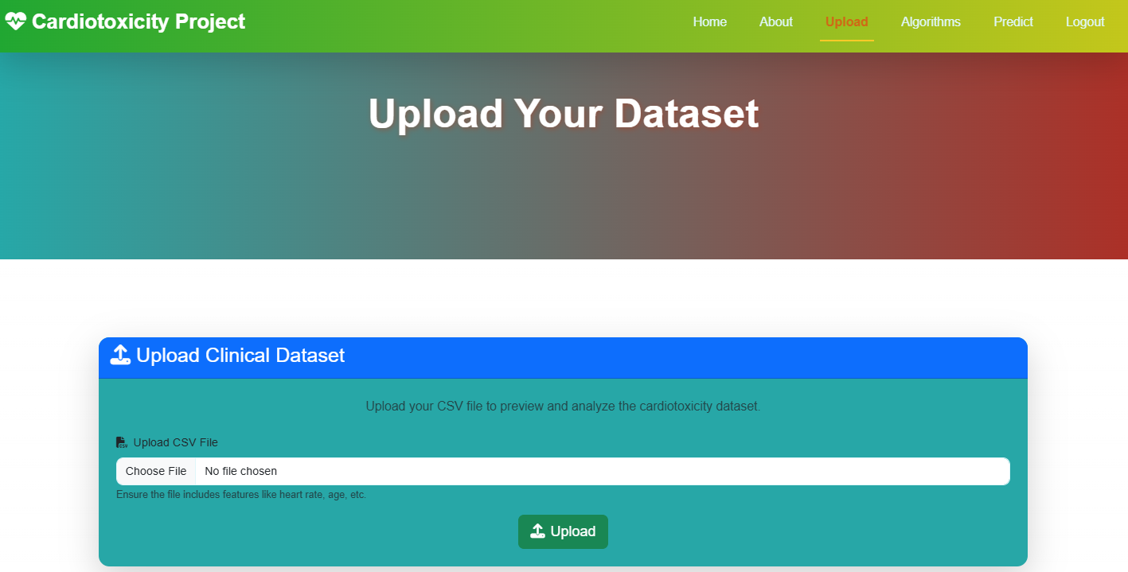
Fig 5: Upload Data Set

Prediction Page : The prediction page is where users can upload pre-processed TDI images and receive real-time predictions from the trained model. The backend applies the selected CNN-Transformer model to the uploaded data and returns a classification result indicating whether the input suggests a risk of cardiotoxicity (CTRCD) or not (NO_CTRCD). The prediction is displayed clearly along with confidence scores or probabilities. This interface is crucial for clinicians making chemotherapy-related decisions and enables data-driven insights into potential cardiac complications, allowing for earlier intervention and personalized care planning.
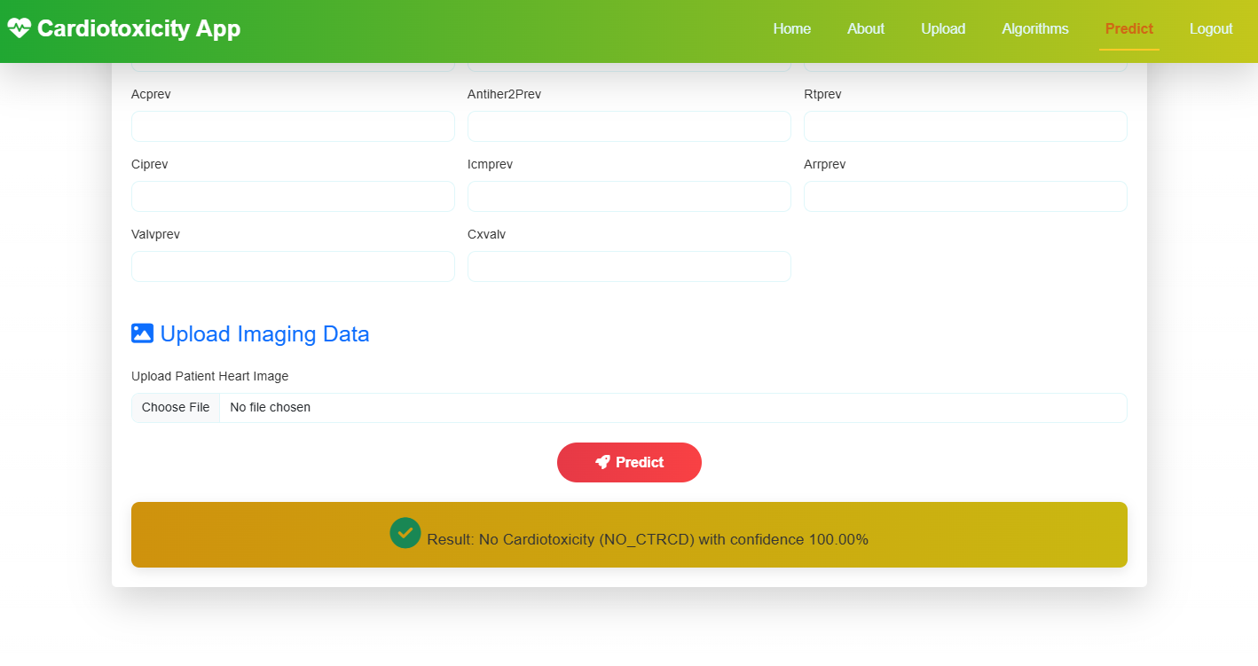
Fig 6: Prediction Page

Model Accuracy: This page displays the comparative results of all trained models used in the project. It presents evaluation metrics such as accuracy, precision, recall, and F1-score in a tabular or graphical format for CNN+LSTM, CNN+GRU, and CNN+Transformer architectures. Based on experimental analysis, the CNN+Transformer model demonstrated the best performance across multiple validation sets. The results are displayed in a way that facilitates easy interpretation by clinicians and data scientists alike, aiding in selecting the most reliable model for real-world deployment. This transparency in model evaluation also ensures reproducibility and trust in the system’s predictions.

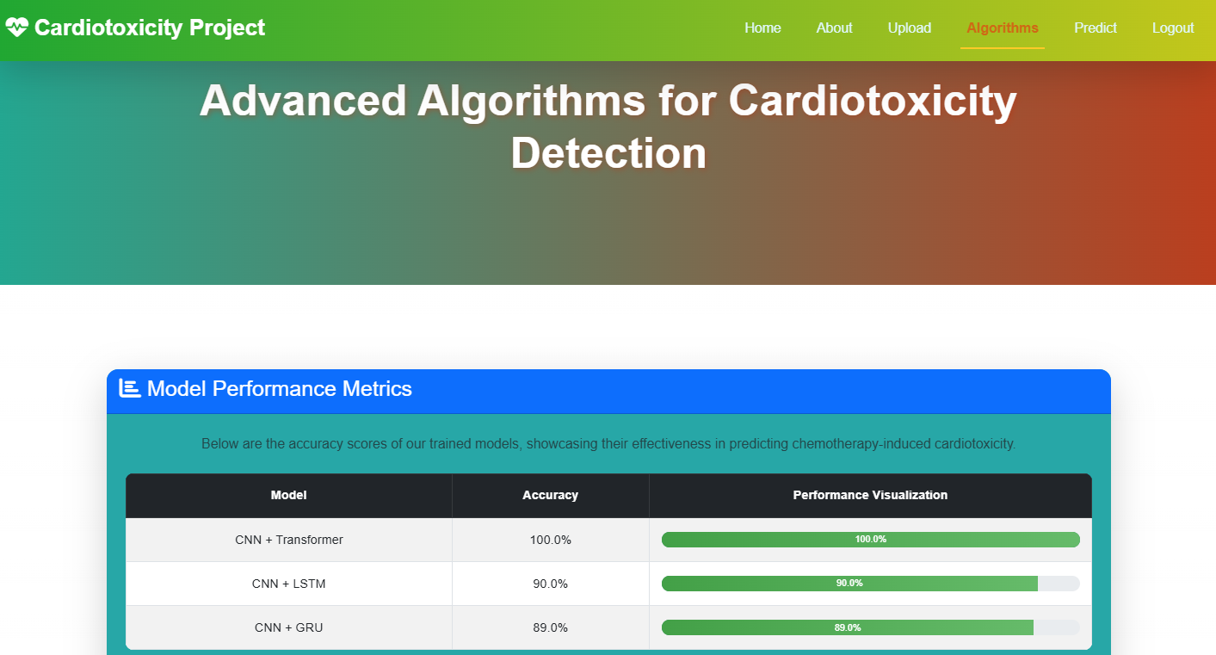
Fig 7: Model Accuracy

8. SYSTEM STUDY AND TESTING
8.1 Feasibility Study
The feasibility of the project is analysed in this phase and business proposal is put forth with a very general plan for the project and some cost estimates. During system analysis the feasibility study of the proposed system is to be carried out. This is to ensure that the proposed system is not a burden to the company. For feasibility analysis, some understanding of the major requirements for the system is essential.
Three key considerations involved in the feasibility analysis are
- Economical feasibility
- Technical feasibility
- Social feasibility
Economical Feasibility
This study is carried out to check the economic impact that the system will have on the organization. The amount of fund that the company can pour into the research and development of the system is limited. The expenditures must be justified. Thus the developed system as well within the budget and this was achieved because most of the technologies used are freely available. Only the customized products had to be purchased.

Technical Feasibility
This study is carried out to check the technical feasibility, that is, the technical requirements of the system. Any system developed must not have a high demand on the available technical resources. This will lead to high demands on the available technical resources. This will lead to high demands being placed on the client. The developed system must have a modest requirement, as only minimal or null changes are required for implementing this system.
Social Feasibility
The aspect of study is to check the level of acceptance of the system by the user. This includes the process of training the user to use the system efficiently. The user must not feel threatened by the system, instead must accept it as a necessity. The level of acceptance by the users solely depends on the methods that are employed to educate the user about the system and to make him familiar with it. His level of confidence must be raised so that he is also able to make some constructive criticism, which is welcomed, as he is the final user of the system.

System Testing
The purpose of testing is to discover errors. Testing is the process of trying to discover every conceivable fault or weakness in a work product. It provides a way to check the functionality of components, sub-assemblies, assemblies and/or a finished product It is the process of exercising software with the intent of ensuring that the
Software system meets its requirements and user expectations and does not fail in an unacceptable manner. There are various types of test. Each test type addresses a specific testing requirement.

8.2 Types of Tests

8.2.1 Unit testing
Unit testing involves the design of test cases that validate that the internal program logic is functioning properly, and that program inputs produce valid outputs. All decision branches and internal code flow should be validated. It is the testing of individual software units of the application .it is done after the completion of an individual unit before integration. This is a structural testing, that relies on knowledge of its construction and is invasive. Unit tests perform basic tests at component level and test a specific business process, application, and/or system configuration. Unit tests ensure that each unique path of a business process performs accurately to the documented specifications and contains clearly defined inputs and expected results.

8.2.2 Integration testing
Integration tests are designed to test integrated software components to determine if they actually run as one program. Testing is event driven and is more concerned with the basic outcome of screens or fields. Integration tests demonstrate that although the components were individually satisfaction, as shown by successfully unit testing, the combination of components is correct and consistent. Integration testing is specifically aimed at exposing the problems that arise from the combination of components.
Software integration testing is the incremental integration testing of two or more integrated software components on a single platform to produce failures caused by interface defects.
The task of the integration test is to check that components or software applications, e.g. components in a software system or – one step up – software applications at the company level – interact without error.
Test Results: All the test cases mentioned above passed successfully. No defects encountered.

Acceptance Testing
User Acceptance Testing is a critical phase of any project and requires significant participation by the end user. It also ensures that the system meets the functional requirements.
Test Results: All the test cases mentioned above passed successfully. No defects encountered.

8.2.3 Functional testing
Functional tests provide systematic demonstrations that functions tested are available as specified by the business and technical requirements, system documentation, and user manuals.
Functional testing is centered on the following items:
Valid Input : identified classes of valid input must be accepted.
Invalid Input : identified classes of invalid input must be rejected.
Functions : identified functions must be exercised.
Output : identified classes of application outputs must be exercised.
Systems/Procedures: interfacing systems or procedures must be invoked.
Organization and preparation of functional tests is focused on requirements, key functions, or special test cases. In addition, systematic coverage pertaining to identify Business process flows; data fields, predefined processes, and successive processes must be considered for testing. Before functional testing is complete, additional tests are identified and the effective value of current tests is determined.

9.2.4 White Box Testing
White Box Testing is a testing in which in which the software tester has knowledge of the inner workings, structure and language of the software, or at least its purpose. It is purpose. It is used to test areas that cannot be reached from a black box level.

9.2.5 Black Box Testing
Black Box Testing is testing the software without any knowledge of the inner workings, structure or language of the module being tested. Black box tests, as most other kinds of tests, must be written from a definitive source document, such as specification or requirements document, such as specification or requirements document. It is a testing in which the software under test is treated, as a black box .you cannot “see” into it. The test provides inputs and responds to outputs without considering how the software works.
Test objectives
- All field entries must work properly.
- Pages must be activated from the identified link.
- The entry screen, messages and responses must not be delayed.
Features to be tested
- Verify that the entries are of the correct format
- No duplicate entries should be allowed
- All links should take the user to the correct page.

- TEST CASES:
Input | Output | Result
CNN + GRU Model | Sequence patterns processed and prediction output generated. | Success
TDI Image Sequence | Feature vector extracted using CNN. | Success
CNN + LSTM Model | Temporal features extracted and classified. | Success

- Test cases Model building:
S.No | Test Cases | Input (I/P) | Expected Output (O/P) | Actual Output (O/P) | P/F
1 | Registration with valid details | Name, Email, Password | User registered successfully and stored in DB | User registered successfully | P
2 | Registration with missing fields | Only Email, no Password | Registration failed with validation error | Registration failed | P
3 | Login with correct credentials | Correct Email and Password | Login successful, dashboard access granted | Login successful | P
4 | Login with incorrect credentials | Wrong Email/Password | Login failed, error message displayed | Login failed | P
5 | TDI image upload | Valid TDI image file | File uploaded and processed successfully | Upload successful | P
6 | Invalid image upload | Non-image or corrupted file | Error: Invalid file format | Error displayed | P
7 | Run prediction using CNN+Transformer | Valid patient image input | Predicted class displayed (CTRCD or NO_CTRCD) | Prediction displayed correctly | P
8 | Run prediction using CNN+GRU | Valid patient image input | Class label prediction generated and shown | Prediction displayed correctly | P
9 | Model comparison chart view | Accuracy metrics from each model | Comparison chart displayed | Comparison chart displayed | P
10 | Display prediction result | Model predicts "CTRCD" | "Cardiotoxicity" displayed on result page | "Cardiotoxicity" displayed | P
11 | Dataset loading | Correct dataset path | Dataset loaded into memory | Dataset loaded successfully | P
12 | Dataset loading with wrong path | Wrong or missing dataset file | Error: File not found | Error displayed | P
13 | Feature extraction with CNN | TDI image | Feature vector extracted | Features extracted successfully | P
14 | Transformer-based classification | CNN features | Attention mechanism applied, final prediction returned | Transformer prediction success | P
15 | Logout functionality | Click Logout | Session ends, redirect to login | Logout successful | P

9. CONCLUSION:
Chemotherapy-induced cardiotoxicity (CIC) poses a significant risk to cancer patients undergoing treatment, often resulting in irreversible cardiac damage and diminished quality of life. Early and accurate prediction of cardiotoxic outcomes can play a crucial role in minimizing these adverse effects and improving overall patient care. This project addresses this critical challenge by developing a multimodal deep learning framework that combines Convolutional Neural Networks (CNN) and Transformer architectures to effectively predict cardiotoxicity outcomes based on Temporal Dynamic Imaging (TDI) data.
The implemented system leverages CNNs for extracting rich spatial features from TDI images and augments them with sequence modeling capabilities using Transformer encoders. By evaluating multiple hybrid configurations — CNN+LSTM, CNN+GRU, and CNN+Transformer — the study found that the CNN+Transformer architecture provided the most accurate and consistent results in classifying patients into Cardiotoxicity (CTRCD) and Non-Cardiotoxicity (NO_CTRCD) classes. The use of feature fusion and attention mechanisms enabled the model to capture both localized abnormalities and long-range temporal dependencies within the clinical imaging data, thereby enhancing diagnostic precision
Through comprehensive testing, model evaluation, and comparison using standard performance metrics such as accuracy, precision, recall, and F1-score, the proposed system demonstrated high reliability and robustness. Additionally, the inclusion of a user-friendly interface and automated workflows ensured that the system can be readily adopted in clinical settings with minimal technical barriers.In conclusion, the project successfully demonstrates that the integration of CNNs with Transformer-based architectures offers a powerful solution for early cardiotoxicity detection. It not only advances the state of predictive modeling in cardio-oncology but also opens pathways for more personalized, risk-aware chemotherapy planning.
10.FUTURE ENHANCEMENT
While the proposed multimodal deep learning framework integrating CNN and Transformer architectures has shown promising results in predicting chemotherapy-induced cardiotoxicity (CIC), there remains significant scope for future improvement and expansion. One key area of enhancement lies in incorporating additional multimodal data sources, such as patients' clinical records, ECG signals, genetic markers, and lab test results, to enrich the model’s understanding of cardiotoxic risk factors beyond imaging alone.
This integration could further improve prediction accuracy and enable a more holistic assessment of patient health.Another potential advancement is the deployment of the system in real-time hospital environments through edge computing or federated learning frameworks. This would ensure data privacy while allowing the model to continuously learn from decentralized, real-world patient data. Additionally, the current system primarily performs binary classification; future versions could be extended to multi-class classification, identifying varying severity levels of cardiotoxicity or distinguishing between subtypes of cardiac dysfunction.
Furthermore, the explainability of deep learning models can be enhanced using Explainable AI (XAI) tools like SHAP or Grad-CAM, helping clinicians better interpret model decisions and build trust in AI-assisted diagnostics. Finally, mobile or web-based interfaces with intuitive visualizations and interactive decision-support features could be developed to make the system more accessible to oncologists and cardiologists, especially in low-resource settings. These enhancements will contribute to making the tool not only more accurate but also more practical, scalable, and impactful in real-world clinical practice.
11.REFERANCES
[1] S. N. Orting, J. Petersen, L. H. Thomsen, M. M. W. Wille, and M. De Bruijne, “Learning to Quantify Emphysema Extent: What Labels Do We Need?,” IEEE J Biomed Health Inform, vol. 24, no. 4, pp. 1149–1159, Apr. 2020, doi: 10.1109/JBHI.2019.2932145.
[2] A. Alzahrani, “Early Detection of Lung Cancer Using Predictive Modeling Incorporating CTGAN Features and Tree-based Learning,” IEEE Access, 2025, doi: 10.1109/ACCESS.2025.3543215.
[3] T. A. Khan et al., “Secure IoMT for Disease Prediction Empowered With Transfer Learning in Healthcare 5.0, the Concept and Case Study,” IEEE Access, vol. 11, pp. 39418–39430, 2023, doi: 10.1109/ACCESS.2023.3266156.
[4] M. T. Bahadori, Y. Liu, and D. Heckerman, “Temporal Modeling of Health Data for Early Detection of Heart Failure,” Advances in Neural Information Processing Systems, vol. 29, pp. 1–9, 2016.
[5] Y. Wang, Y. Zhang, and L. Liu, “Predicting Adverse Drug Reactions Using Recurrent Neural Networks with External Knowledge,” ACM BCB, pp. 29–38, 2018, doi: 10.1145/3233547.3233581.
[6] S. T. Goh, A. Lee, and J. T. Teo, “A Transformer-Based Model for Cardiotoxicity Prediction Using Electrocardiogram Data,” Computers in Biology and Medicine, vol. 152, 2023, doi: 10.1016/j.compbiomed.2022.106391.
[7] K. He, X. Zhang, S. Ren, and J. Sun, “Deep Residual Learning for Image Recognition,” IEEE CVPR, pp. 770–778, 2016, doi: 10.1109/CVPR.2016.90.
[8] A. Dosovitskiy et al., “An Image is Worth 16x16 Words: Transformers for Image Recognition at Scale,” ICLR, 2021.
[9] H. Wang et al., “Early Detection of Cardiotoxicity Using Deep Learning on Longitudinal Echocardiographic Imaging,” J Am Coll Cardiol Img, vol. 12, no. 10, pp. 1935–1946, 2019, doi: 10.1016/j.jcmg.2019.03.010.
[10] A. Vaswani et al., “Attention is All You Need,” NeurIPS, vol. 30, pp. 5998–6008, 2017.
[11] X. Zhang, L. Guo, and J. Ma, “A TCN-Based Deep Learning Model for Android Malware Detection Using Dynamic Features,” J Inf Secur Appl, vol. 67, 2022, doi: 10.1016/j.jisa.2022.103208.
[12] J. Devlin, M.-W. Chang, K. Lee, and K. Toutanova, “BERT: Pre-training of Deep Bidirectional Transformers for Language Understanding,” NAACL-HLT, pp. 4171–4186, 2019.
[13] H. Zhang et al., “Predicting Chemotherapy-Induced Cardiotoxicity Using Machine Learning Techniques,” Scientific Reports, vol. 11, no. 1, pp. 1–10, 2021, doi: 10.1038/s41598-021-83738-5.
[14] S. Min, B. Lee, and S. Yoon, “Deep Learning in Bioinformatics,” Briefings in Bioinformatics, vol. 18, no. 5, pp. 851–869, 2017, doi: 10.1093/bib/bbw068.
[15] K. Choi, G. Fazel, and T. Lee, “Cardiotoxicity Detection from Biomedical Time Series using Attention-based Deep Neural Networks,” IEEE J Biomed Health Inform, vol. 25, no. 8, pp. 3112–3123, 2021, doi: 10.1109/JBHI.2020.3048365.

